The Economic and Financial Environment of Business Decision Making
Name
Institution
Date

The Economic and Financial Environment of Business Decision Making
Section A
Question 1
Minimum wage is defined as the minimum remuneration that an employer can pay wage earners for their labor services offered during a given period. Individual contracts or by collective agreement cannot be used to negotiate minimum wage. The primary aim of minimum wage is to protect employees from uncharacteristically low wages and ensure equitable sharing of economic gains to all. Policymakers also enforce minimum wage policies to reduce inequality (especially between genders, ages, or races) and overcome excessive poverty. Minimum wage policies represent powerful political tools, although the economic impact is less likely to benefit society at all. Ideally, wages should be left to be determined by the natural operation of market forces. According to Gough (2017), minimum wage limits have been identified as effective within low-wage sectors such as the hospitality sector.
The labor market behaves similarly to the market of goods and services through the forces of demand and supply. The law of demand-supply in the labor market at higher wages (high labor price) results in decreased demand for labor by employers. On the other hand, at lower wages (low labor price), the quantity of labor demanded by employers increases. Therefore, the law of supply for labor shows that high wages result in a high quantity of labor supply while low wages result in a low quantity of labor supply. To illustrate the impact of minimum wage, I will use a hypothetical number of registered nurses in Baltimore.

Wage
Supply
Minimum 1

W_{e}

Minimum 2

Demand

Quantity
Q_{e}

- W_{e} is equilibrium wage without intervention by Government

- Q_{e} is equilibrium quantity without intervention by Government

The horizontal axis represents the number of nurses employed, where labor is measured using the number of nurses employed or the number of labor hours supplied. The vertical axis represents the labor price or the level of wages paid to nurses. The price of nurse labor in this example is measured as annual wages plus benefits. As nurse wages increase, the quality of labor demanded by employers fall. The reason is that some hospitals, nursing homes, and clinics reduce the number of nurses employed. As a result, they decide to lay off some of the existing nurses rather than pay them higher wages. Alternatively, employers may choose to replace labor-intensive nurse functions with machines or employ less costly clinical aides to reduce the number of nurses needed.
On the other hand, when nurses' wages increase, the number of nurses willing to provide their services increases (Ruesga-Benito, González-Laxe & Picatoste, 2017).. If the salaries of nurses within Baltimore increase at a higher rate than other cities or regions, nurses will move to Baltimore for better employment opportunities. Besides, there will be more people willing to train as nurses or take nursing full time jobs leading to increased supply of nurses. At the equilibrium, the quantity of labor supplied equals the quantity of labor demanded. As a result, every employer willing to hire nurses at the equilibrium wage will find a willing worker, and every nurse willing to deliver services at the equilibrium wage can find a job. Assuming there are 35,000 registered nurses working within a variety of employers in the city, including hospitals, schools, nursing homes, health clinics, and doctors' offices. We and Qe represent the equilibrium wage, and equilibrium quantity of labor supplied and demanded in the market. When natural forces of demand and supply are allowed to work out, the 35,000 nurses will be employed at the equilibrium wage determined by demand and supply forces. For instance, assume the equilibrium wage is $70,000, then all employers will be willing to offer nurses these wages, and all nurses will be willing to accept and work for such wages. Therefore, the equilibrium wage is $70,000, and the equilibrium quantity is 35,000.
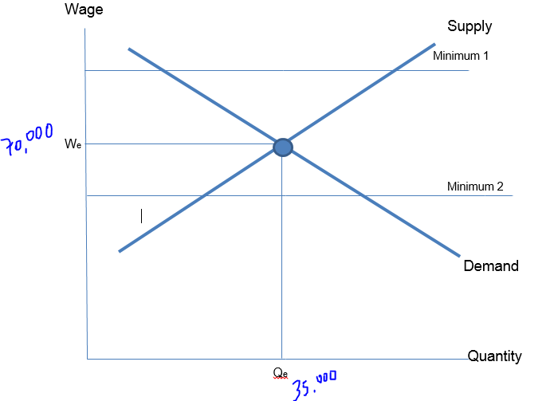
Now, what happens when the Government imposes minimum wages for nurses above the equilibrium wage (minimum wage 1)? For example, at a minimum wage above the equilibrium wage, say $75,000, the quantity of labor supplied will increase to about 40,000. In contrast, the amount of nurses demanded by employers at such wages decreases to about 27,000. The wage level above the equilibrium creates a situation of excess labor supply.
The opposite happens when the Government enacts minimum wage legislation below the equilibrium wage (minimum wage 2). For instance, if the Government imposes a minimum wage of $60,000, which is below equilibrium, then the quantity of nurses willing to offer their services declines to about 33,000. On the contrary, the quantity of labor demanded by employers at low increases to 38,000 nurses. At the below equilibrium wage, there exists excess demand and nurse supply shortage.
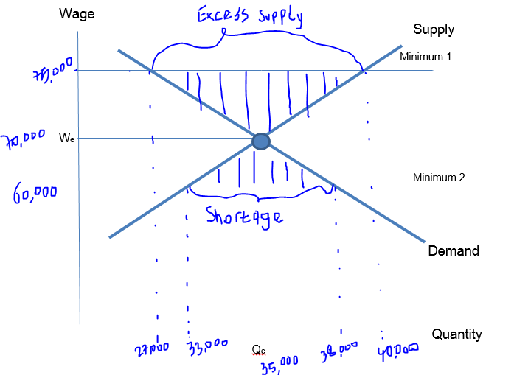

References
Gough, J. (2017). The Impact of Minimum Wage Legislation. World Economics, 18(1), 107-122.
Ruesga-Benito, S. M., González-Laxe, F. I., & Picatoste, J. (2017). The debate on the economic effects of minimum wage legislation. European Journal of Government and Economics, 6(2), 171-190.

Section B
Question 2
Hospitality Sector
The hospitality industry (restaurants, pubs, and hotels) have suffered severely under the ongoing Covid-19, with most businesses closing up and employees being laid off. Since the onset of the pandemic, approximately 100,000 were laid off, representing approximately half of the industry (Stankov, Filimonau & Vujičić, 2020). The hospitality industry represents a significant component of the Irish economy. As we approach the post-pandemic era, the sector is expected to experience massive transformations concerning demand and supply. Ireland has consistently outperformed most of the European countries over the years leading up to Covid-19. The sector is driven by extensive macroeconomic fundamentals contributing significantly to the country's GDP through production and employment.
These fundamentals demonstrated over the years, contributing to increased household savings; the demand for domestic and international leisure is expected to resume once the industry reopens. Post-pandemic will signal an increased number of players within the sector reopening their businesses. Similarly, eliminating movement and social distance restrictions will encourage more and more households to seek hospitality services leading to increased demand for their services. The scenario of the hospitality sector presents an elastic demand and supply context. As more businesses are expected to reopen their businesses, more and more consumers are expected to seek their services.
However, there are reservations concerning how corporate travels and their spending on hospitality services will unfold. As Stankov, Filimonau & Vujičić (2020) notes, speculations are surrounding how the significant adoption of digital telecommunications will affect corporate travels. A decline in corporate travel represents a significant proportion of lost demand for Ireland's hospitality sector. However, whether corporate travels reduce, it is important to note that the demand drivers post-pandemic will definitely exceed any impact related to decreasing corporate travels.
Retail Sector
The retail sector worldwide represents one sector that continues to reverberate due to the seismic effects of the Covid-19. As the pandemic struck the world, stores were shuttered overnight, and businesses transformed from brick and mortar to e-commerce. According to Bradley et al. (2021), apparel overstocking and grocery hoarding soon opened doors to new business practices and consumer behavior that continue to reshape the retail world. The pandemic promoted online businesses contributing to significant jolts in performances while leading to a devastating decline of others. But a close look at the industry shows that the consumers continued to enjoy retail services.
The supply for the services and goods suffered a significant setback at the onset of the pandemic and following the imposition of movement restrictions and social distance measures. However, the sector has reshaped with time, and suppliers have continued to provide goods and services to consumers through innovative means. In reality, the sector has outperformed other sectors during the pandemic, with most players recording positive investment returns (Bradley et al., 2021). The pandemic acted as a catalyst for sector realignment. Most of the demand for retail goods and services has been met through sector realignment. As a result, the sector is expected to experience inelastic demand and supply post-pandemic.
Understandably, most brick-and-mortar stores are expected to reopen. However, there will also be a general decline in the number of players offering online services. As the demand for brick-and-mortar goods and services is expected to improve after the cessation of movement restrictions, a proportionally equal decline in the demand for online retail goods and services is expected. The bottom line is that the sector operates at almost optimal levels, with sector leaders such as Amazon, Tesco, and Argos expanding their value and widening the gap with small players. Hence, minor changes in demand and supply are expected post-covid-19.
References
Bradley, C., Kohli, S., Kuijpers, D., & Smith, T. (2021). Why retail outperformers are pulling ahead. mckinsey. Retrieved 4 August 2021, from https://www.mckinsey.com/industries/retail/our-insights/why-retail-outperformers-are-pulling-ahead.
Stankov, U., Filimonau, V., & Vujičić, M. D. (2020). A mindful shift: an opportunity for mindfulness-driven tourism in a post-pandemic world. Tourism Geographies, 22(3), 703-712.

Question 4 (a)
Economic interdependence and inter-relationships is a situation where different countries are economically dependent on each other. Interdependence among countries arises as a product of labor specialization meaning different countries can produce different products because jobs are specialized. Economic interdependence is borne when one country specializes in producing certain products another country needs but cannot produce. Now, governments will continue to produce the products they can produce efficiently to export surplus and import the products they need but cannot produce adequately. Alternatively, not all countries possess the raw materials they need to produce certain products. As a result, they will need to import such raw materials from other countries. As a result, countries and their economies become dependent on goods and services from other countries. For instance, China has become a global economic player by accounting for approximately 20 percent of global GDP. Ireland is among the world's leading exporters of computer software. However, it depends on other countries for transport equipment and machinery, petroleum and petroleum products, chemicals, textile, and food products.
Question 4 (b)
Chang & Kastner (2017) noted that financial flows and trade across countries play a significant role in explaining linkages among world economies. Economic interdependence through trade contributes a substantial proportion of GDP in many countries. Different companies from many countries tend to look for growth opportunities beyond their borders. As a result, international trade creates a sense of economic stimulation, for instance, in ICT and transport. Therefore, economic interdependence is important for business because it creates new opportunities for growing revenues, increasing market share, and business expansion. Besides, economic interdependence through trade has resulted in globalization over the years. People from different countries can travel across the border, interact, network, and socialize. The increase in locally available goods and services widens the range of goods and services for consumers to choose from (Chang & Kastner, 2017). As a result, businesses cannot overlook economic interdependence because of the numerous opportunities from growth provided by foreign markets.
However, economic interdependence also comes with negative impacts. These adverse effects are intensely felt by small economies, especially during sudden, unexpected, external shocks. Small economies such as Ireland find it hard to adequately produce all needed goods and services for their citizens due to a lack of adequate resources (human and capital). As a result, small economies continue to rely on big economies like Germany, China, and the United States to import goods and services. However, these small economies could face challenges when faced with sudden, unexpected, external shocks. For instance, several world events such as the Euro and United States crises have demonstrated the spillover effects of economic performance on other countries. At the same time, the significance of China on the sustenance of the world economy was clearly demonstrated during the covid-19 pandemic.
During shocks, the greatest challenge facing the small economies is supply interruption, leading to shortages in products and services. With Ireland relying on china, the United States, and other European countries for major products, it is worth analyzing the impact of external shocks on its economy. China experienced the first coronavirus outbreak in Wuhan. The region produces global pharmaceutical supplies (Mylan and Pfizer), which signaled disruption in production and subsequent distribution of pharmaceutical products globally (Taylor, 2020). Similarly, with some countries closing their borders and bringing international interactions to a halt, it becomes difficult for small economies to export their products to other countries. Countries that lack diversified economies and depend on the export of natural resources (e.g., agricultural products and oil) could face economic collapse. Ireland has a significantly grown hospitality sector which was greatly impacted by covid-19 due to the sudden collapse of international tourism to minimize the spread of the disease.
References
Chang, H. J., & Kastner, S. L. (2017). Economic interdependence and conflict. In Oxford Research Encyclopedia of Politics.
Taylor, C. (2020). Cliff Taylor: Coronavirus means Ireland's economic outlook hangs in the balance. The Irish Times. Retrieved 4 August 2021, from https://www.irishtimes.com/opinion/cliff-taylor-coronavirus-means-ireland-s-economic-outlook-hangs-in-the-balance-1.4188079.

